 | Contents list avaliable at Directory of Open Access Journals (DOAJ)  Al-Ishlah: Jurnal Pendidikan  ISSN: 2087-9490 (Printed); 2597-940X (Online)  Journal Homepage: http://www.journal.staihubbulwathan.id/index.php/alishlah | 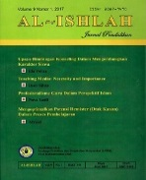

Development of Interactive Multimedia Based On Powerpoint in Science Learning in Elementary School

Sania Putriana , Nellitawati , Alwen Bentri , Nur Azmi Alwi

DOI:

Article Info | Abstract
Keywords:  Development  Interactive multimedia  PowerPoint  Kata kunci:  Pengembangan  Multimedia Interaktif  PowerPoint | This study discusses the development of interactive multimedia learning media based on PowerPoint software in science learning in elementary schools. This study aims to produce interactive multimedia media, especially in science learning in elementary schools that are valid, practical and effective. The type of research used is Research and Development (RnD). That is the development of interactive multimedia based on PowerPoint software in science learning. The development model used is the ADDIE model ( Analyze, Design, Development, Implementation and evaluation ). The output of interactive multimedia based on PowerPoint Software is in the form of files that can be installed easily, making it easier for students in the learning process. Based on the research results, this interactive multimedia is valid, practical and effective  Abstrak  Penelitian ini membahas tentang pengembangan media pembelajaran multimedia interaktif berbasis software PowerPoint pada pembelajaran IPA di Sekolah Dasar. Penelitian ini bertujuan untuk menghasilkan media multimedia interaktif khususnya pada pembelajaran IPA di Sekolah Dasar yang valid, praktis dan efektif. Jenis penelitian yang digunakan adalah Research and Development (RnD). Yaitu pengembangan multimedia interaktif berbasis software PowerPoint pada pembelajaran IPA. Model pengembangan yang digunakan adalah model ADDIE (Analyze, Design, Development, Implementation dan evaluation). Output dari multimedia interaktif berbasiswa Software PowerPoint ini berupa file yang dapat di intall dengan mudah, sehingga memudahkan siswa dalam proses pembelajaran. Berdasarkan hasil penelitian, multimedia interaktif ini sudah valid, praktis dan efektif

INTRODUCTION
According to Law No. 20 of 2003, education is a conscious and planned effort in creating a learning atmosphere and learning process so that students actively develop their potential to have religious spiritual strength, self-control, personality, intelligence, noble character and skills needed by themselves, society, and society. nation and state.
Education in Elementary school contains several subjects. Some of the subjects between others, namely Religious Education, Indonesian, Education Citizenship, Mathematics, Science (Natural Science), Art Culture and Craft, Social Studies (Science Social), as well as Education Physical Sports and Health. One of the subjects at the elementary school level is Natural Sciences (IPA). Science is one of the subjects in Elementary School (SD) whose object of study is related to human life. In create IPA materials that are creative, innovative, effective and fun it should be teacher creates an product in the form of learning media which is right . The learning process in elementary schools should emphasize more on direct experience to students, in accordance with the statement (Yanti: 2017) that the learning process emphasizes providing direct experience to develop competence in order to explore and understand the natural surroundings scientifically .
Learning media is a kind of material ( material), devices , settings, equipment and people where students can interact directly with the media which has the aim of facilitating learning and changing in the direction of better performance in learning. Philosophically, this interactive-based learning media needs to be developed because it can help teachers in the learning process . With this interactive multimedia-based learning media it contains colored pictures with display that attract students to be more enthusiastic in learning .
Theoretically, there are several experts who state that how important it is that this interactive multimedia-based learning media is developed , because this interactive multimedia-based learning media has advantages. According to Fatmala (2016: 4) the advantages of interactive multimedia-based learning media are: (1) Students can interact directly with learning media. This learning media can support student learning activities effectively independent . This learning media can be operated using a computer, laptop, and cellphone or tablet, (2) Overall this media contains Basic Competencies (KD), science learning materials, sounds, animations, pictures, and questions to evaluate students' understanding of the material provided.
In making this interactive multimedia-based learning media, it is necessary to use applications and software , including PowerPoint , Canva, Powtoon, Prezi, Sparkol Videoscribe, Lectora, Sigil, Wondershare Filmora. Of all these applications and software , researchers use PowerPoint software . The researcher chose this PowerPoint software because it has several advantages over other applications, namely (1) in making media you do not have to be connected to the internet, (2) it is not expensive, (3) it is not paid, (4) there is no need to install an application because PowerPoint is in all windows computers or laptops, so that teachers and students can easily access them, (5) can be applied and accessed anywhere, such as computers, laptops, or cellphones (HP).
Based on The results of observations made by researchers at schools indicate that SDIT Nurul Ilmi Pariaman has a computer laboratory. There are several gaps that occur during the learning process. Among them in the learning process the teacher only uses learning resources from books curriculum 2013 . There is no teacher using the computer as a means of learning or learning media . The limited knowledge of teachers in developing learning media based on interactive multimedia causes students to be passive in learning .
Teacher has not created media which is more innovative so that it makes learning feel boring . This can be seen by the lack of enthusiasm for student in subject science , because student does not have a real picture about how process material in subject science occurs I'm in the natural around the real. Therefore , media is very important i to support learning
The use of media based on interactive multimedia has not been used in science learning, so students have difficulty understanding subject matter that is conceptual, symptomatic and principled in science material. Therefore, teachers should make learning as interesting as possible, especially in science learning. An example is by using PowerPoint . In this case, the interactive location in PowerPoint is in the practice questions, where every student who answers correctly or incorrectly will be given an emoticon reply that has been provided as a feedback from the answers given by students.
students who have difficulty understanding the material will cause the learning objectives not to be achieved in meetings because time is limited , so that it will add to the burden of the next material . This is because the students ' interest in learning is still lacking so that students have difficulty understanding the material . In the learning process students only as recipients of information from teacher because the technique learning uses verbal communication makes student feel bored . Students who lack get ample opportunity to convey their ideas or ideas , develop their experiences and potential. And the lack of interaction between students and teacher when the teacher explains the lesson because students do only see text or readings and only listen to explanation from the teacher .
From the results of the MID semester 1 science subjects for class V SDIT Nurul Ilmi Kota Pariaman for the 2021/2022 academic year, with a Minimum Completeness Criteria (KKM) of 80, there are still 13 people or 56% of students who are declared incomplete. While 10 people or 44% who just reached the KKM of 23 students. Empirically, based on the problems that have been described previously, it is not in accordance with the expected learning. Based on the background explanation above , there are problems in class V, especially in learning science . Therefore, the researchers chose science subjects and class V as the object of research. So that the researcher is interested for to conduct research and development with title "Development of PowerPoint Software - Based Interactive Multimedia on Science Learning in Elementary Schools".

METHODS
This type of research is a type of research development ( Research and Development ) which is oriented on products developed in education fields which aims to improve effectiveness and understanding material students in learning nor the result. Study use model study which adapted from the ADDIE development model (Analyze , Design, Develop, Implement, and Evaluate). The ADDIE model began to exist in the 1990s which was developed by Dick and Carry.
Instrument is used to collect data during the process of developing interactive multimedia-based learning media in the form of questionnaires , documentation and student learning outcomes tests . The questionnaire was prepared covering three types adapted to respondents from the study. The questionnaires are questionnaires for validity testing by material and media experts , questionnaires for practicality tests by students , and effectiveness tests through evaluation of student learning outcomes.
This research uses several techniques for data collection , namely observations, interviews, documentation, questionnaires and tests .The data obtained through activities trials in testing the validity and practicality of interactive multimedia based on PowerPoint software are grouped into two, namely qualitative data and quantitative data. Data Qualitative in the form of critique and suggestions which were put forward by the validator and the students were gathered to improve this interactive multimedia-based learning media product. Quantitative data obtained from the questionnaire was then converted to quantitative data with scale 5 (Likert scale) for to know the quality of product with the following description .

Table 1. Likert Scale Quantitative Data
Aspect | Symbol | Mark
Very good _ | (SB) | 5 i
ok i | (B) | 4 i
Enough i Good | (CB) | 3 i
less i | (K) | 2 i
Very i Less | (SK) | 1 i

Furthermore , the results of the questionnaire are analyzed by by looking for the average rating . Obtaining the average score from each component aspect assessment with using the formula :
x̄=$\frac{\sum{x}}{n}$
where :
x̄ | = | Average i Score i
P | = | The number of total scores of each component
N | = | Total i validator/evaluator i
(Sugiyono, 2016:43)

Conversion scale the five are using the reference conversion on Approach Reference Benchmark (PAP) which developed by Eko (2009: 238) as table below this :

Table 2. Conversion of i Value
Quantitative Data | Score |  | Criteria
Quantitative Data | Formula | Average Score | Criteria
5 | X > Xi + 1.8 Sbi | X > 4.2 | I'm very good
4 | Xi + 0.6 Sbi < X Xi + 1.8 Sbi | 3,4 < X 4.2 | ok i
3 | Xi - 0.6 Sbi < X Xi + 0.6 Sbi | 2.6 < X 3.4 | Enough i
2 | Xi - 1.8 Sbi < X Xi - 0.6 Sbi | 1.8 < X 2.6 | less i
1 | X Xi - 1.8 Sbi | X 1.8 | I really lack
Source: i Eko i Putro i Widoyoko i (2009: i 238)

In this research is determined value feasibility product with a minimum of " 3.4" with category "Good", so that results from research, both from experts in material, experts in media, and students, if has obtained final assessment results with minimum value , then product as the result of the development is considered worthy to be used.

FINDINGS AND DISCUSSION
- Development of Interactive Multimedia Learning Media
In accordance with the objectives and development procedures used in the research that the researcher has carried out, the data obtained from the research are as follows.
- Stage of Analysis (Analysis)
- Needs Analysis
- Analysis of Student Needs and Problems
- Analysis of Student Characteristics
- Institutional Needs Analysis
- Target Analysis
- Curriculum Analysis
- Revision
- Design Phase ( Design )
- Determining Media Development Software
- Selecting a Presentation Format
- Making interactive multimedia-based learning media
- The initial view contains the subject title, class and start navigation buttons.
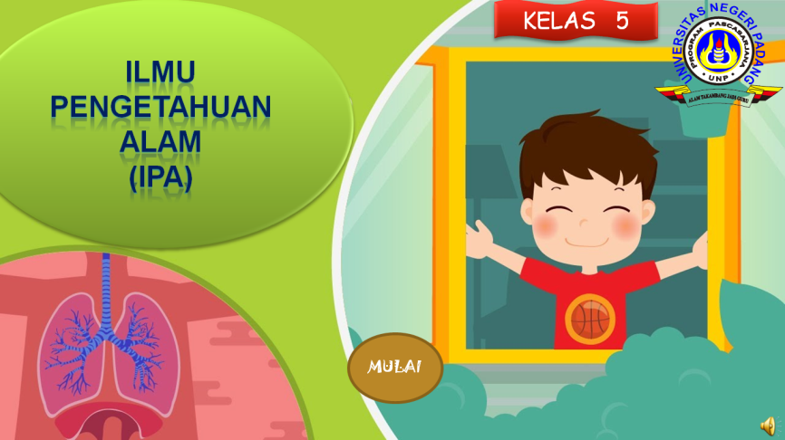
Figure 1. Initial Product Appearance
- After the user clicks the "start" navigation button, the user will enter the menu page. On this page there are several menus that students will choose from including instructions, indicators, materials, questions and profiles.
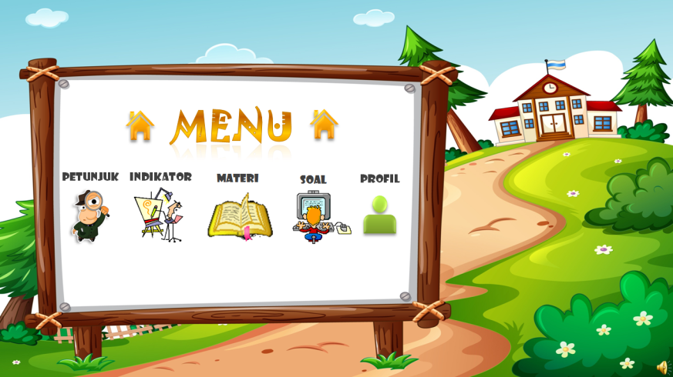
Figure 2. Menu display
- Hint Display
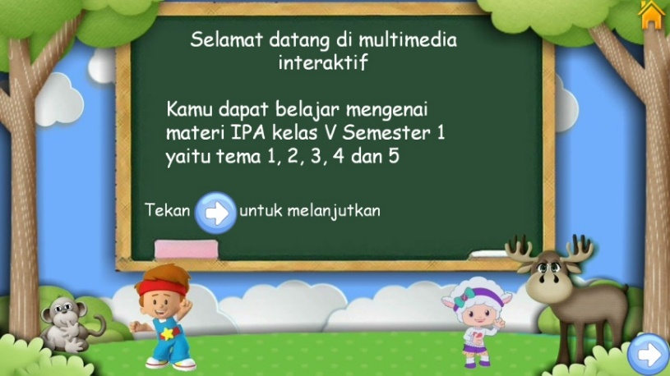
Figure 3 . Hint Display k

- Indicator Display
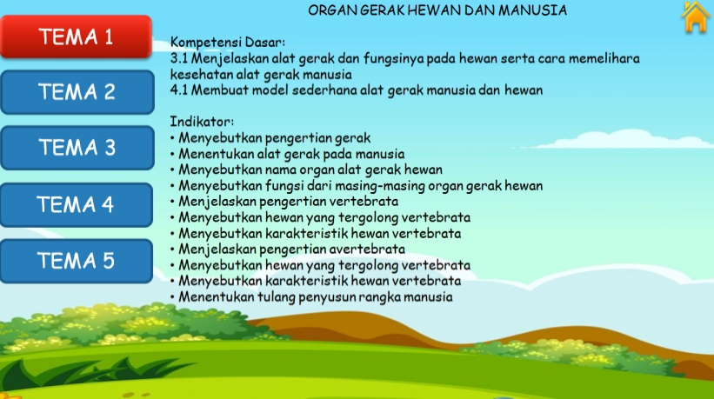
Figure 4 . Display indicators _

- Material Display
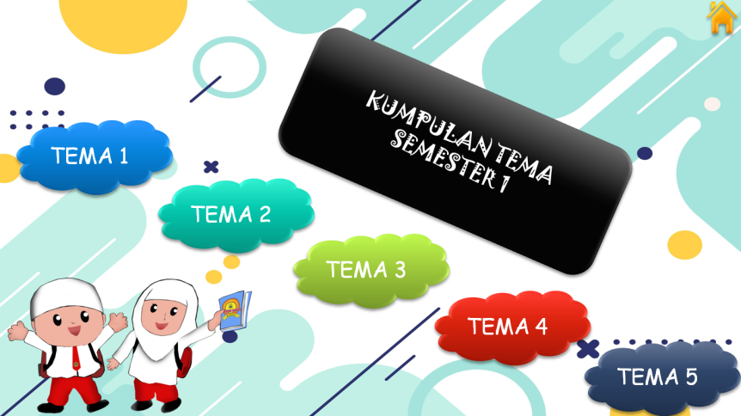
Figure 5 . Material display
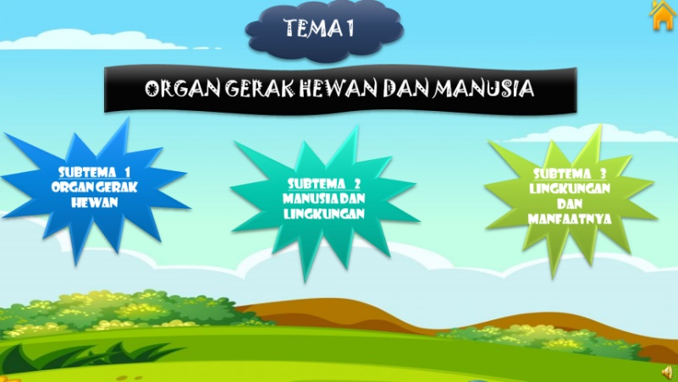
Figure 6 . Display sub-theme title
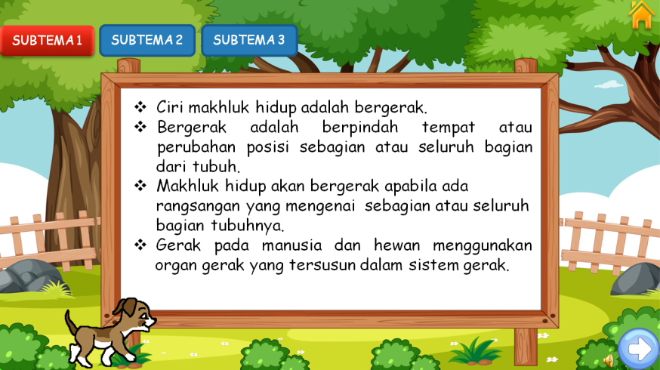
Figure 7. Material display
- Question Display
The question display contains the intro display for themes 1, 2, 3, 4 and 5 as shown in the following picture
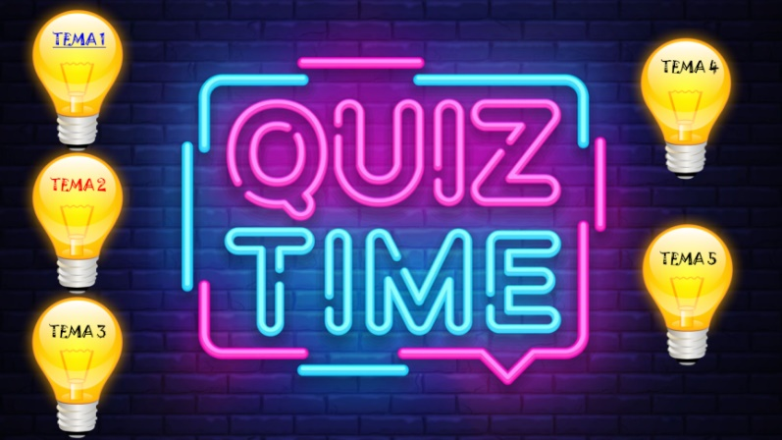
Figure 8 . Initial view of the first question
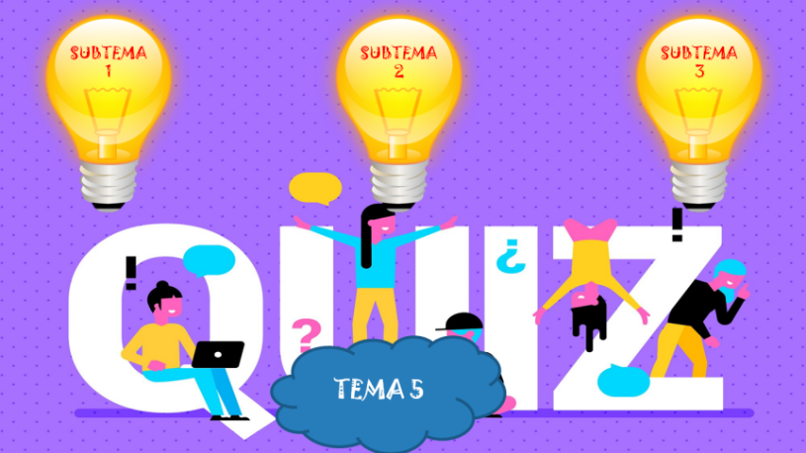
Figure 9 . Initial appearance of the subject matter
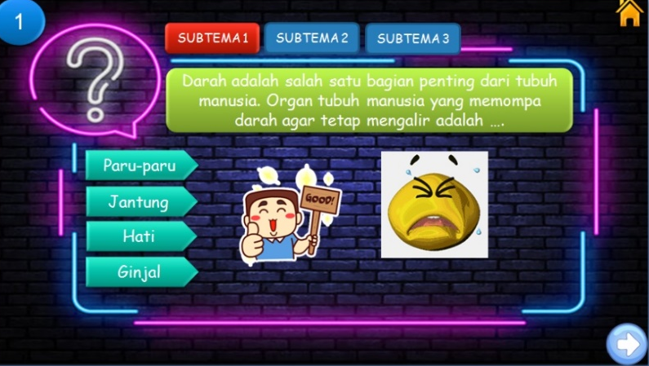
Figure 10. Question display

- Profile
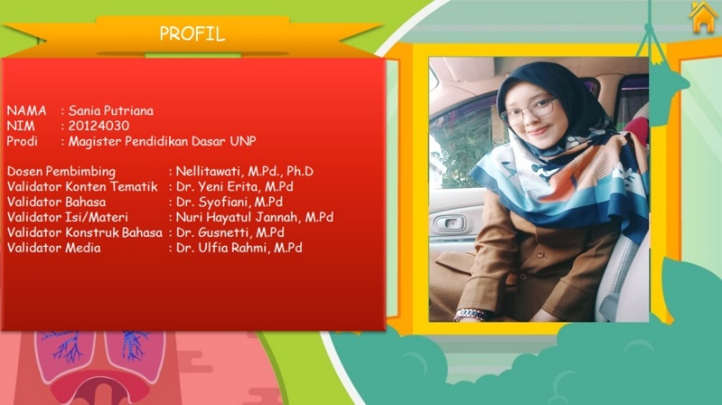
Figure 1 1 . Profile View
- Designing Media i with Various Animations and Images.
- Compiling Questionnaire
- Development Phase ( Development )
The interactive multimedia development stage based on PowerPoint software includes validity and practicality tests .
- Implementation ( implementation )
This implementation phase tests the effectiveness of interactive multimedia. In development research to see the effectiveness or product trials can be done by experimentation , namely by comparing the effectiveness of the old work system with the effectiveness of the new work system.
Data analysis aims to explain the results of the trial data. The test results are used as the basis for revising the developed materials.

- Validity Data Analysis
Table 3 . Overall validation results
Validator | Average | Category | Interactive Multimedia Validity
Thematic Content Expert | 4 | Well | 4, 38 (Very Good)
Linguist | 4.8 | Very good | 4, 38 (Very Good)
Content Expert | 4 | Well | 4, 38 (Very Good)
Language Constructor | 5 | Very good | 4, 38 (Very Good)
Media Expert | 4.1 | Well | 4, 38 (Very Good)
From the validity results with an average of 4.38 , it can be said that interactive multimedia based on PowerPoint software is "very good". Thus, interactive multimedia based on PowerPoint software is already valid for testing.
- Practical Data Analysis
Table 4 . Overall practical results
Validator | Average | Category | Interactive Multimedia Practical
Teacher | 4.8 | Very good | 4.7 (very practical)
Student | 4.7 | Very good | 4.7 (very practical)

From the practical results with an average of 4.7 , it can be said that interactive multimedia based on PowerPoint software is "very practical". Thus, interactive multimedia based on PowerPoint software is already practical to use in testing effectiveness.
- Effectiveness Data Analysis
Table 5 . Posttest calculation data
No | Descriptive statistics | Pretest | Posttest
1 | Average | 70 | 86
2 | Standard deviation | 8.96 | 6.76
3 | variance | 80.28 | 45.67
4 | Lowest value | 40 | 73
5 | The highest score | 80 | 93

The test results obtained stated that 91% of the number of fifth grade students at SDIT Nurul Ilmi scored above the KKM after using interactive multimedia based on PowerPoint Software. Based on the previous researcher's determination that if 85% of the number of fifth grade students at SDIT Nurul Ilmi get a score above the KKM after using interactive multimedia based on PowerPoint software , then this product is declared effective. This is in accordance with what was stated by Sugiyono (2016), that the new work system will be effective if the value after treatment is greater than the value before treatment. Based on the research results, interactive multimedia based on PowerPoint software is effective for increasing students' knowledge .

CONCLUSION
After conducting the research, the research data were then analyzed, so that from the data analysis it can be concluded that the results are as follows:
- Based on the results of the validator, interactive multimedia based on PowerPoint software got an average score of 4.38 with the criteria of "Very Good". Thus, interactive multimedia based on PowerPoint software that has been developed is very valid and can be used for the learning process, especially science learning for grade 5 semester 1.
- PowerPoint software-based interactive multimedia is very practical to use. This is known from the results of practicality by giving a questionnaire to 1 teacher and 11 students at SDIT Nurul Ilmi Pariaman City. The average score of the teachers is 4.8 with the criteria of "Very Good", the average score of the students is 4.7 with the criteria of "Very Good". Thus, interactive multimedia based on PowerPoint software gets an average score of 4.7 with the criteria of "Very Practical". This means that grade 5SD students are greatly helped in understanding the material by learning to use interactive multimedia based on PowerPoint software.
- PowerPoint software-based interactive multimedia is very effective to use. This is known from the results of the students' pretest and posttest. The test results obtained stated that 91% of the number of fifth grade students at SDIT Nurul Ilmi scored above the KKM after using interactive multimedia based on PowerPoint Software. Based on the previous researcher's determination that if 85% of the number of fifth grade students at SDIT Nurul Ilmi get a score above the KKM after using interactive multimedia based on PowerPoint software , then this product is declared effective. Based on the results of the analysis, interactive multimedia based on PowerPoint software is effective for increasing students' knowledge.

REFERENCES
Abdullah, R. (2012). Pembelajaran Berbasis Pemanfaatan Sumber Belajar. Jurnal Ilmiah Didaktika, 12(2), 216–231..https://doi.org/10.22373/jid.v12i2.449
Agnezi, L. A. 2019. Validitas, Reliabilitas, Praktikalitas, dan Efektifitas Bahan Ajar Non Cetak Meliputi: Audio, Audio Visual, Video, Multimedia, Display (Berbasis ICT). Jurnal INA-Rxiv, 9(1), 156-176.https://osf.io/preprints/inarxiv/y843x/
Ahmadi, F. 2010. Meningkatkan Minat Membaca Siswa Sekolah Dasar Dengan Metode Glenn Doman Berbasis Multimedia. Jurnal Penelitian Pendidikan, 27(1), 57-77.
Ali, M. 2009. Pengembangan Media Pembelajaran Interaktif Mata Kuliah Medan Elektromagnetik. JurnalEdukasi Elektro, 5(1), 11-18.
Alwasilah, A. Chaedar. 2009. Pokoknya Kualitatif. Jakarta: Pustaka Jaya.
Anggraeni, Nurul 2015. Pengembangan Media Pembelajaran Berbasis Multimedia Interaktif Menggunakan Adobe Flash CS5 untuk SMK Kelas XI Kompetensi Keahlian Administrasi Perkantoran pada Kompetensi Dasar Menguraikan Sistem Informasi Manajemen. Yogyakarta: Universitas Yogyakarta
Annisa, N., & Simbolon, N. 2018. Pengembangan Media Pembelajaran Interaktif Ipa Berbasis Model Pembelajaran Guided Inquiry Pada Materi Gaya Di Kelas Iv Sd Negeri 101776 Sampali. School Education Journal Pgsd0Fip0Unimed,08(2),0217–229. https://doi.org/10.24114/sejpgsd.v8i2.10199
Arikunto, S. 2013. Prosedur Penelitian: Suatu Pendekatan Praktik. Jakarta:
Rineka Cipta.
Arsyad, Azhar. 2016. Media Pembelajaran. Jakarta: Raja Grafindo Persada
Basuki, I. H. 2014. Assesment Pembelajaran. Bandung: PT. Remaja Rosda Karya.
Beni Pekei. 2016. Konsep dan Analisis Efektivitas Pengelolaan Keuangan Daerah
di Era Otonomi. Buku 1. Jakarta Pusat : Taushia
[BSNP] Badan Standar Nasional Pendidikan. 2007. Peraturan Menteri Pendidikan Nasional Republik Indonesia Nomor 41 Tahun 2007 Tentang Standar Proses untuk Satuan Pendidikan Dasar dan Menengah. Jakarta: BSNP.
Constantinescu, I. 2007. Using technology to assist in vocabulary acquisition and Reading comprehension. The Internet TESL Journal, 8(2), 161-181 http://iteslj.org/Articles/Constantinescu-Vocabulary.html
Daryanto. 2013. Media Pembelajaran. Yogyakarta: Gava Media.
Darmodjo, Hendro. 1992. Pendidikan IPA 2. Jakarta: Depdikbud
Deni Darmawan. 2012. Inovasi Pendidikan. Bandung: Remaja Rosdakarya.
Dewi, M. D., & Izzati, N. 2020. Pengembangan Media Pembelajaran PowerPoint Interaktif Berbasis RME Materi Aljabar Kelas VII SMP. Delta: Jurnal Ilmiah Pendidikan Matematika, 8(2),217-237.https://doi.org/10.31941/delta.v8i2.1039
Dewi, K. T, Suastra. I. W. & Pujani, N. M. 2013. Pengaruh Model Pembelajaran Analyze, Design, Develop, Implement, Evaluate (ADDIE) Terhadap Ketrampilan Berpikir kritis dan pemahaman Konsep Fisika.E-Journal Program Pascasarjana Universitas Pendidikan Ganesha Program Studi IPA, 3(1), 1-10.
Dina Indriana. 2011. Ragam Alat Bantu Media Pengajaran. Yogyakarta: DIVA
Press.

Dian. 2016. Pengaruh Penggunaan Multimedia Interaktif terhadap Kemampuan Pemahaman Konsep Matematis Siswa. FIBONACCI
Eka, I. P. 2013. Teknologi Media Pembelajaran Sejarah Melalui Pemanfaatan Multimedia Animasi. Jurnal TEKNOIF, 01(02), 1–6.
Ekayani, P. (2017). Pentingnya Penggunaan Media. Jurusan PGSD Fakultas Ilmu Pendidikan, 3(2), 24-44 https://www.researchgate.net/publication/315105651
Fathurrahman, Pupuh, 2007. Strategi Belajar Mengajar. Bandung: Refika Aditama
Fatmala, D., & Yelianti, U. (2016). Pengembangan Media Pembelajaran Multimedia Interaktif Berbasis Android pada Materi Plantae untuk Siswa SMA Menggunakan Eclipse Galileo. Biodik, 2(1), 1–6. https://www.online-journal.unja.ac.id/biodik/article/download/3356/8309/6808
Festiyed. 2017. Evaluasi Pembelajaran Fisika. Padang: Sukabina Press.
Fitria, Y. (2017). Efektivitas Capaian Kompetensi Belajar Siswa Dalam Pembelajaran Sains Di Sekolah Dasar. Jurnal Inovasi Pendidikan Dan Pembelajaran Sekolah Dasar, 1(2). https://doi.org/10.24036/jippsd.v1i2.8605
Hadi, S. 2017. Efektivitas Penggunaan Video Sebagai Media Pembelajaran untuk Siswa Sekolah Dasar. Prosiding TEP & PDs, 1(15), 96–102.
Hamalik, 1994. Media Pendidikan. Bandung : Citra Aditya Bakti
Harjono, A., Gunawan, & Sutrio. (2015). Multimedia Interaktif dalam Pembelajaran Konsep Listrik Bagi Calon Guru. Jurnal Pendidikan Fisika Dan Teknologi, 1(1), 9–14. https://jurnalfkip.unram.ac.id/index.php/JPFT/article/view/230/226
Hendryadi. 2017. Validitas Isi: Tahap Awal Pengembangan Kuesioner. Jurnal
Riset Manajemen dan Bisnis (JRMB) Fakultas Ekonomi UNIAT, 2(2),
Irfan, I., Muhiddin, M., & Ristiana, E. (2019). Pengembangan Media Pembelajaran IPA Berbasis PowerPoint di Sekolah Dasar. Indonesian Journal of Primar, 3(2), 16–27...https://ejournal.upi.edu/index.php/IJPE/article/view/21765
Iqbal, Al-Furqan., Zelhendri, Zen. 2017. Pengembangan Media Pembelajaran Berbasis Autoplay Media Studio pada Tema Berbagai Pekerjaan di Kelas IV SD. Inovtech, 2(1), 21-41 https://doi.org/10.1007/XXXXXX-XX-0000-00
Krismasari, R. E. (2016). Lampiran 1 Lembar Validasi Angket siswa dan Hasil Validasi. http://eprints.umpo.ac.id/1783/8/LAMPIRAN.pdf
Kumalasari, M. P. 2018. Kepraktisan Penggunaan Multimedia Interaktif pada Pembelajaran Tematik Kelas IV SD. Jurnal Bidang Pendidikan Dasar (JBPD),02(1),01–11. http://ejournal.unikama.ac.id/index.php/JBPD/article/view/2345/1726
Mahmudi. 2016. Manajemen Kinerja sektor publik.Yogyakarta: UPP AMP
YKPN.
Mardiasmo. 2017. Perpajakan. Yogyakarta: Andi.
Maslichah, Asy’ari. 2006. Penerapan Pendekatan Sains Teknologi Masyarakat
dalam Pembelajaran Sains di Sekolah Dasar. Yogyakarta: Universitas
Sanata Dharma
Matondang, Z. 2009. Validitas dan Reliabilitas suatu Instrumen Penelitian.
JURNAL TABULARASA PPS UNIMED, 6(1), 163-183
Mayer, Richard. E. (2009). Multimedia Learning. Yogyakarta: PustakaPelajar.
Mudani, Yudhi. 2012. Media Pembelajaran. Jakarta: Gaung Persada (GP) press
Munir. 2008. Kurikulum Berbasis Teknologi Informasi dan Komunikasi. Bandung: Alfabeta.
Mutia, R., & Halim, A. 2017. Pengembangan Video Pembelajaran Ipa Pada Materi Pencemaran Dan Kerusakan Lingkungan. Jurnal Pendidikan Sains Indonesia 5(2), 108–114. https://doi.org/10.24815/jpsi.v5i2.9825
Mulyasa, H. E. 2013. Pengembangan dan Implementasi Kurikulum 2013.
Bandung: Remaja Rosdakarya
Nadiyah, R. S., & Faaizah, S. 2015. The Development of Online Project Based Collaborative Learning Using ADDIE Model. Procedia - Social and Behavioral0Sciences,05(2),01803–1812.https://doi.org/10.1016/j.sbspro.2015.06.392
Novitasari, D. 2015. Pengaruh Penggunaan Multimedia Interaktif terhadap Kemampuan Pemahaman Konsep Matematis Siswa 2 (2), 8-18. https://jurnal.umj.ac.id/index.php/fbc/article/view/1650/1402
Nurrita, T. 2018. Pengembangan Media Pembelajaran untuk Meningkatkan Hasil Belajar Siswa. 3(1), 171-187.
https://pps.iiq.ac.id/jurnal/index.php/MISYKAT/article/view/52/37
Nurseto, T. 2012. Membuat Media Pembelajaran yang Menarik. Jurnal Ekonomi Dan Pendidikan, 8(1), 19–35. https://di.org/10.21831/jep.v8i1.706
Onintra, P. 2009. Evaluation of Educational Multimedia support System for Students with Deafness. Journal of Educational Multimedia and Hypermedia, 8(1), 71-90.
Paseleng, M. C., & Arfiyani, R. 2014. Pengimplementasian Media Pembelajaran Berbasis Multimedia Interaktif Pada Mata Pelajaran Matematika di Sekolah Dasar. Scholaria. 5(2), 131 – 149...............................................
https://ejournal.uksw.edu/scholaria/article/view/22/20
Permana, E. P., & Nourmavita, D. 2017. Pengembangan Multimedia Interaktif Pada Mata Pelajaran Ipa Materi Mendeskripsikan Daur Hidup Hewan Di Lingkungan Sekitar Siswa Kelas IV Sekolah Dasar. Jurnal PGSD, 10(2), 79–85. https://doi.org/10.33369/pgsd.10.2.79-85
Priyanto, D. 2009. Pengembangan Multimedia Pembelajaran Berbasis Komputer. 14(1), 1–13.
Putra, D. R., & Nugroho, M. A. 2016. Pengembangan Game Edukatif Berbasis Android Sebagai Media Pembelajaran Akuntansi Pada Materi Jurnal Penyesuaian Perusahan Jasa. Jurnal Pendidikan Akuntansi Indonesia, 14(1), 155-175. https://doi.org/10.21831/jpai.v14i1.11364
Rahayu, C., & Festiyed. 2018. Validitas Perangkat Pembelajaran Fisika SMA berbasis Model Pembelajaran Generatif dengan Pendekatan Open-Ended Problem untuk Menstimulasi Keterampilan Berpikir Kritis Peserta Didik. Jurnal Pendidikan Fisika, 7(1), 154-174.
Republik Indonesia, 2003. Undang-Undang Republik Indonesia Nomor 20 Tahun 2003 tentang Pendidikan. Jakarta: Kementerian Riset, Teknologi, dan Pendidikan Tinggi.
Sadiman, Arief. S. dkk. 2014. Media Pendidikan. Jakarta: Raja Grafindo
Samhudi. 2021. Pengembangan Media Pembelajaran Berbasis Teknologi Informasi. Jurnal Ilmiah, 1(1), 146-163. http://jurnal.staikha.ac.id/index.php/contoh/article/view/12
Samodra, D. W., V. Suhartono, & S. Santosa. 2009. Multimedia Pembelajaran Reproduksi pada Manusia. Jurnal Teknologi Informasi, 5(2), 695-710.
Santoso, Anang. 2014. Materi dan Pembelajaran Bahasa Indonesia SD. Tengerang Selatan: Universitas Terbuka
Sari, P. (2019). Analisis terhadap kerucut pengalaman Edgar Dale dan keragaman gaya belajar untuk memilih media yang tepat dalam pembelajaran. Mudir: Jurnal Manajemen Pendidikan, I(1), 58–78. https://ejournal.insud.ac.id/index.php/MPI/article/view/27
Sari, R. K., & Harjono, N. 2021. Pengembangan Media Pembelajaran Interaktif Berbasis Articulate Storyline pada Mata Pelajaran IPA Siswa Kelas VII. Mimbar0Ilmu,04(1),0122–130. https://ejournal.undiksha.ac.id/index.php/MI/article/view/31555
Setiadi, H. (2016). Pelaksanaan penilaian pada Kurikulum 2013. Jurnal Penelitian Dan Evaluasi Pendidikan, 20(2), 166–178. https://doi.org/10.21831/pep.v20i2.7173
Simanjuntak, E. Y. B., Silitonga, E., & Aryani, N. 2020. Pelatihan Pembuatan Media Pembelajaran Interaktif dengan Menggunakan PowerPoint. Jurnal Abdidas, 1(3), 119–124.
Soenarto, Sunaryo. 2011. Pembelajaran Berbasis Multimedia sebagai Upaya Meningkatkan Kompetensi Hasil Belajar dan Persepsi Mahasiswa. Skripsi. Yogyakarta: Universitas Sanata Dharma
Sucipto, 2010. Penulisan Naskah Pembelajaran Multimedia Interaktif Berbantuan Komputer (Multimedia). Makalah. Yogyakarta: Balai Teknologi Komunikasi Pendidikan (BTKP).
Sugiyono. 2016. Statistika untuk Penelitian. Bandung: Alfabeta
Sukmadinata, Nana Syaodiyah. 2010. Metode Penelitian Pendidikan. Bandung: PT. Remaja Rosdakarya.
Susanto, N. R.D, A.I. 2013. Pengembangan Multimedia Interaktif Dengan Education Game Pada Pembelajaran Ipa Terpadu Tema Cahaya Untuk Siswa SMP/MTs. USEJ - Unnes Science Education Journal, 2(1), 230–238.
Sutarno. 2011. Penggunaan Multimedia Interaktif pada Pembelajaran Medan Magnet untuk Meningkatkan Keterampilan Generik Sains Mahasiswa. Jurnal Exacta, 9(1), 60-66.
Usman, Samatowo. 2006. Bagaimana membelajarkan IPA di SD. Jakarta: Depdiknas Dikti
Wati, Ega Rima. 2016. Ragam Media Pembelajaran. Jakarta: Kata Pena
Widayat, Widi. 2014. Pengembangan Multimedia Interaktif Sebagai Media Pembelajaran Ipa Terpadu Pada Tema Sistem Gerak Pada Manusia. USEJ - Unnes Science Education Journal, 3(2), 535–541. https://doi.org/10.15294/usej.v3i2.3353
Widoyoko, S. Eko Putro. 2009. Evaluasi Program Pembelajaran. Yogyakarta: Pustaka Belajar
Wijayanti, W., & Christian Relmasira, S. 2019. Pengembangan Media PowerPoint IPA Untuk Siswa Kelas IV SD Negeri Samirono. Jurnal Penelitian Dan Pengembangan Pendidikan, 3(2), 77-97..https://doi.org/10.23887/jppp.v3i2.17381
Wiyono, K., A. Setiawan., A. Suhadi. 2009. Model Pembelajaran Multimedia interaktif Relativitas Khusus untuk Meningkatkan Keterampilan Generik Sains Siswa SMA. Jurnal Penelitian Pendidikan IPA, 3(1), 21-30.
Yulia Sari, L. (2016). Uji Efektivitas Media Pembelajaran Interaktif Berorientasi Konstruktivisme Pada Materi Neurulasi Untuk Perkuliahan Perkembangan Hewan. Bioconcetta, 2(1), 158–164....................................
Yusuf, A. M. (2015). Asesmen dan Evaluasi Pendidikan. Jakarta: Kencana

Universitas Negeri Padang, Email: saniaputriana@gmail.com
Universitas Negeri Padang Email: nellitawati@fip.unp.ac.id
Universitas Negeri Padang Email: alwenbentri@fip.unp.ac.id
Universitas Negeri Padang Email: nurazmialwi@fip.unp.ac.id

